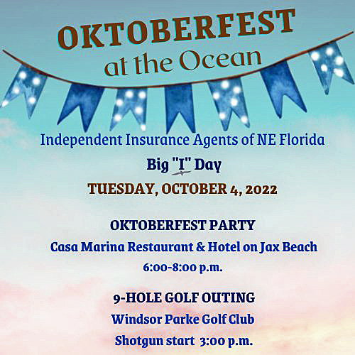
Big “I” Day 2022 SPONSORSHIP OPPORTUNITIES
Special thanks to Presenting Sponsor: Southern Oak Insurance

GOLF OUTING
Beverage Sponsor: $400 One of two available. Thank you, Southbay Acceptance Corp.
(recognition on drink tickets at golf and at party, signage, complimentary dinner registration)
Hole-in-One Prize Sponsor: $400 (recognition on course and at dinner; complimentary dinner registration; signage)
Award Prize Sponsor: $400 (recognition on course and at dinner; complimentary dinner registration; signage)
Hole Sponsors: $300 (signage on the course; complimentary dinner registration) Only 5 available at this time!

OKTOBERFEST ON THE OCEAN PARTY
Dinner and Entertainment: Thank you, AmWINS
Chance Auction Sponsor: $500 (recognition at raffle; logo on the raffle tickets; complimentary dinner registration). Auction benefits the IIANF Career Outreach and InVEST programs.
Grand Prize Sponsor: $400 Thank you, Olympus Insurance

AUCTION DONATIONS: Donate CA$H to purchase a prize for the Auction $______________________
OR Donate an AUCTION ITEM at the party: _______________________________________
COMPANY _____________________________________________________________
CONTACT _____________________________EMAIL _______________________________________
Make check payable to: IIANF & mail to IIANF, PO Box 24570, Jacksonville FL 32241 or request invoice to margy@iianf.com Deadline is September 21st. Please forward your company logo to margy@iianf.com, as soon as possible. THANK YOU!

