Independent Insurance Agents of NE Florida’s Big “I” Day
Tennis Tournament & Dinner Registration
Thursday, OCTOBER 7, 2021
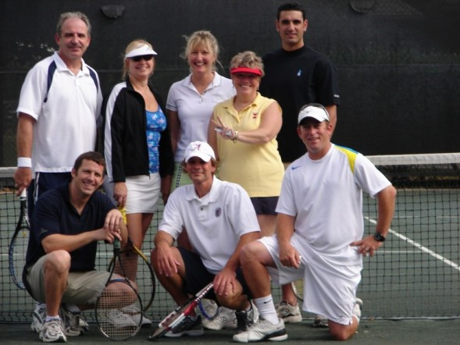

BIG “I” DAY VENUE: Deercreek Country Club Tennis Complex, 7816 McLaurin Road, N., Jacksonville 32256

TENNIS TOURNAMENT & CASINO DINNER PARTY PACKAGE INCLUDES:
- Round Robin play at Deercreek Country Club Tennis Complex
- Starting time TBD (possibly 1:30 pm)
- Clinic with the Pro prior to tournament play
- Drinks and snacks on-court
- Awards Reception (food & beverages, prizes)
- Player Swag Bags
- CASINO DINNER PARTY (6-8 pm) buffet dinner, casino tables, drink tickets, prizes!

TENNIS OUTING & DINNER FEE: $100 (includes ticket to the Casino Dinner Party)
TENNIS SPONSORSHIP (Includes tennis registration and dinner): $150**
REGISTRATION: Please register & pay by September 15th. Complete and mail or scan and email to info@iianf.com
PLAYER NAME | LEVEL | COMPANY | EMAIL

PAYMENT: Complete this form and mail check with this form (check payable to IIANF) to:
IIANF, PO Box 24570, Jacksonville FL 32241 OR use PayPal at www.iianf.com

Interested in donating item(s) for the Player Swag Bag?
Yes, count me in with an item(s) for the Swag Bag!
COMPANY NAME: ____________________________
ITEM(S): _________________________________

**If you are sponsoring the Tennis Outing, please provide your company’s logo. We accept all file formats. Please send by September 15th to margy@iianf.com Thank you!

