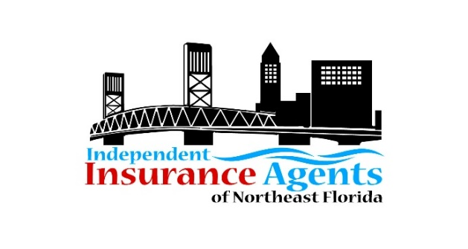
2024 MEMBERSHIP APPLICATION AND RENEWAL FORM
ANNUAL DUES ARE PAYABLE IN JANUARY 2024

Agency/Company Name: _____________________________________________
Local Mailing Address:________________________________________________
City, State, and Zip: __________________________________________________
Agency Principal or Company Representative: _____________________________
___________________________________________________________________
Email: _____________________________________________________________
Phone: ___________________________________________________________
Website/LinkedIn/Facebook group pages:_________________________________ ___________________________________________________________________
Anyone else you want to receive IIANF information, updates, reminders, etc.? ___________________________________________________________________
Email(s): ___________________________________________________________
Number of Employees in your office: ___________
Please complete this form and send it with annual dues payment to IIANF, P.O. Box 24570, Jacksonville FL 32241 by January 31, 2024. Make check payable to IIANF.
You may email this completed form to margy@iianf.com. Please provide your company logo by emailing to margy@iianf.com Questions? Call IIANF at 904-993-7176 or email.

Thank you for your membership!

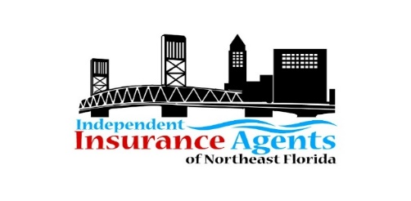2024 MEMBERSHIP DUES
Agency Membership: Dues are based on annual written premiums. Note, dues have not increased in the past nine years! Membership includes access to Lunch and Learn Series, Quarterly Meetings, Networking Events, Charitable Events, and Continuing Education Classes, and Big “I” Day registration discounts.

Associate Membership: Associate Members includes sponsorship of IIANF program, C.E. class, meeting, Lunch ‘n Learn Series, or Big I Day golf bay or hole. Let us know your preference or if you have an event you’d like to sponsor that is not listed.

Individual Membership: Open to licensed agents in solo agencies, between careers, or new in the industry.

Legislative: The IIANF participates in local and state legislative initiatives and provides an updated list of critical issues relevant to the insurance industry and independent agents.

Education and Training: IIANF supports workforce development training, mentorship, and scholarships and offers various educational training for its members and associates.

Sponsorship Opportunities
Choose your company’s preference.
Lunch and Learn Series Session ($300 value) held quarterly
Big I Day Hole/Bay ($400 value) on Thursday, Oct. 3, 2024
Continuing Education Class ($400 value) held bi-monthly.
Quarterly Membership Meeting or Networking Event ($400 value)
ASSOCIATE MEMBER DUES
Associate Membership includes sponsorship of a program, C.E. Class, meeting, or Big I Day. Please indicate your preference.
ANNUAL DUES | EDUCATION (OPTIONAL) | LEGISLATIVE (OPTIONAL) | TOTAL DUE  $50 discount applied if paid by 01/31/2024
$450 | $100 | $100 | $625.00 includes $50 discount

If paying by check, please make check payable to IIANF and mail to IIANF, Post Office Box 24570, Jacksonville FL 32241. If paying by credit card (via PayPal invoice), please request an invoice by emailing margy@iianf.com.

